**Lab Sheet - 06**

**IT24103082**

**Medhani M.A.T**

**Part 01**

**(01)**

**(02)**

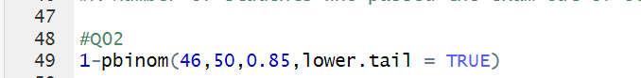

**Part 02**

**(01)**

**(02)**

**(03)**

